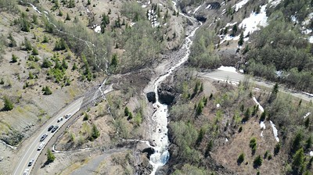

**QR code for US Forest Service Website
South Coldwater Slide Information**

**Gifford Pinchot National Forest Information**

Website: <http://www.fs.usda.gov/goto/gp/coldwaterslide>

News and Alerts: <https://www.fs.usda.gov/alerts/giffordpinchot/alerts-notices/?aid=80265>

Sign up for news updates: <https://www.fs.usda.gov/detail/giffordpinchot/home/?cid=fseprd998833>

Facebook:  <https://www.facebook.com/GiffordPinchot/>

Twitter: <https://twitter.com/gpnf>

**Washington State Department of Transportation Information**

Website: <https://wsdot.wa.gov/construction-planning/search-projects/sr-504-landslide-bridge-washout>

Sign up for email updates: <https://public.govdelivery.com/accounts/WADOT/subscriber/new>

Facebook: <https://www.facebook.com/WSDOT/>

Twitter: <https://twitter.com/wsdot/>

Flickr: <https://www.flickr.com/photos/wsdot/>